**SOFTWARE REQUIREMENT SPECIFIACTION**

**ONLINE BANKING SYSTEM**

**Name: Priya Natesan (ACE2068)**

**Date : 18/09/2013**

**CONTENTS**

|  |  |  |
| --- | --- | --- |
| **S.No** | **Title** | **Page No** |
| 1 | Objectives | 3 |
| 2 | Modules | 4 |
| 2.1 | Common Modules | 4 |
|  | Log in | 4 |
|  | Change Password | 5 |
|  | Forgot password | 6 |
| 2.2 | Admin Module | 6 |
|  | Account Creation | 7 |
|  | Managing Account | 8 |
|  | Viewing account details | 8 |
|  | Editing account details | 8 |
| 2.3 | Account Holder Module | 8 |
|  | Balance Enquiry | 9 |
|  | Fund Transfer | 10 |
|  | Mini Statement | 11 |
| 3 | Database Design | 12 |

**Online Banking System**

1. **Objective:**

The Online Banking deals with the maintenance banking process in online. There are two types of end users for this application.

1. Admin.

There is only one admin. Admin manages the users of the system.

1. Account holder.

Account holder can manage their account corresponding to the bank. Account holder can have only one account. Account holder can access their account registering after registration. The user Id, account no, password, default security question id and answer will be given by the admin after registration.

The system has the following functionalities.

|  |  |  |
| --- | --- | --- |
| S.No | Functionality | Availability |
| 1 | Log in | Both admin and account holder can do this functionalities |
| 2 | Forgot password |
| 3 | Change password |
| 4 | Update Security Question |
| 4 | Account creation | Only admin can do these functionalities |
| 5 | Managing account(Editing and deleting) |
| 6 | Balance enquiry | Only account holder can do these functionalities |
| 7 | Mini statement |
| 8 | Fund transfer |

1. **Modules**

**Common Modules:**

**Log In:**

This module deals with the process of user login. The user should provide the correct user name and password for proper log in. Once the user logged in they can perform the banking services allowed by the system. The user can be of Administrator or the Account holder. Login process checks for the type of user. Then the system provides corresponding services to the user.

**Main Home Page:**

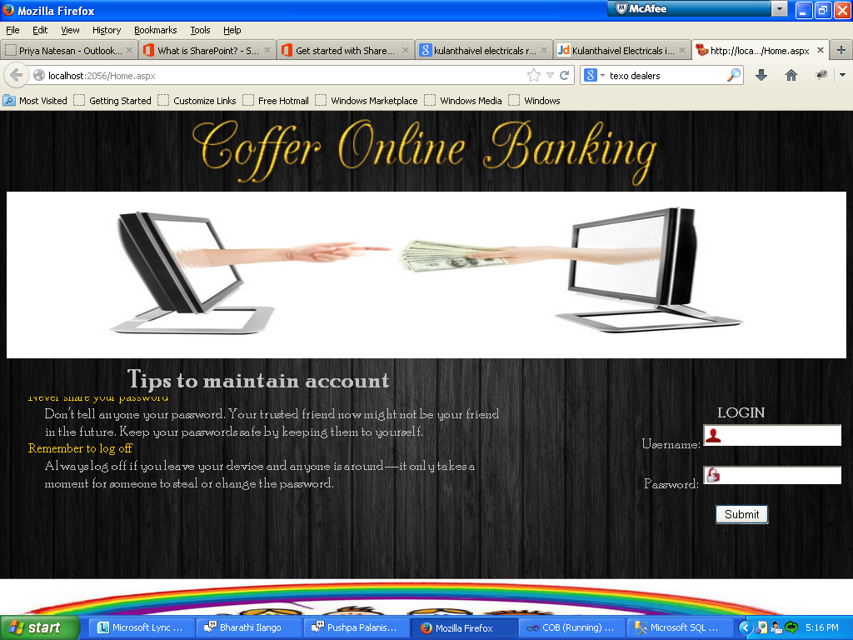

**Change Password:**

This module provides a facility to the user to change the account password. This process verifies the user’s old password and allows changing password for security purposes.

**Change Password Page:**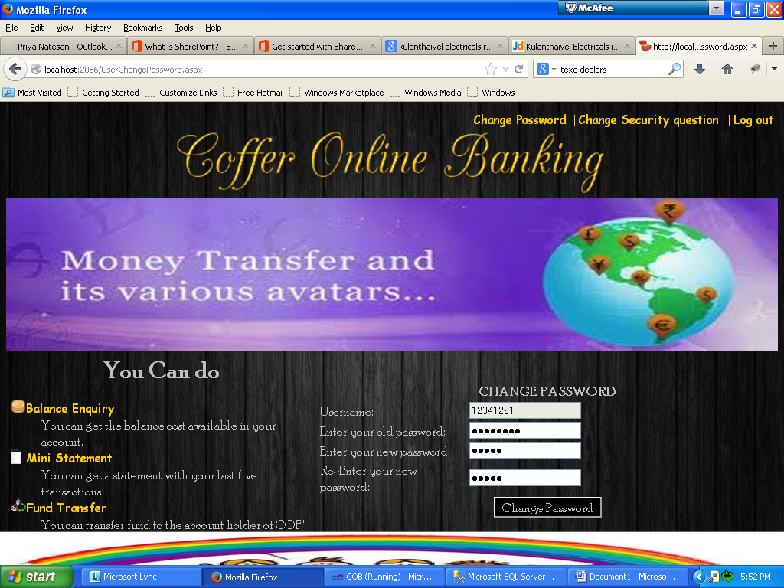

**Change Password Success Page:**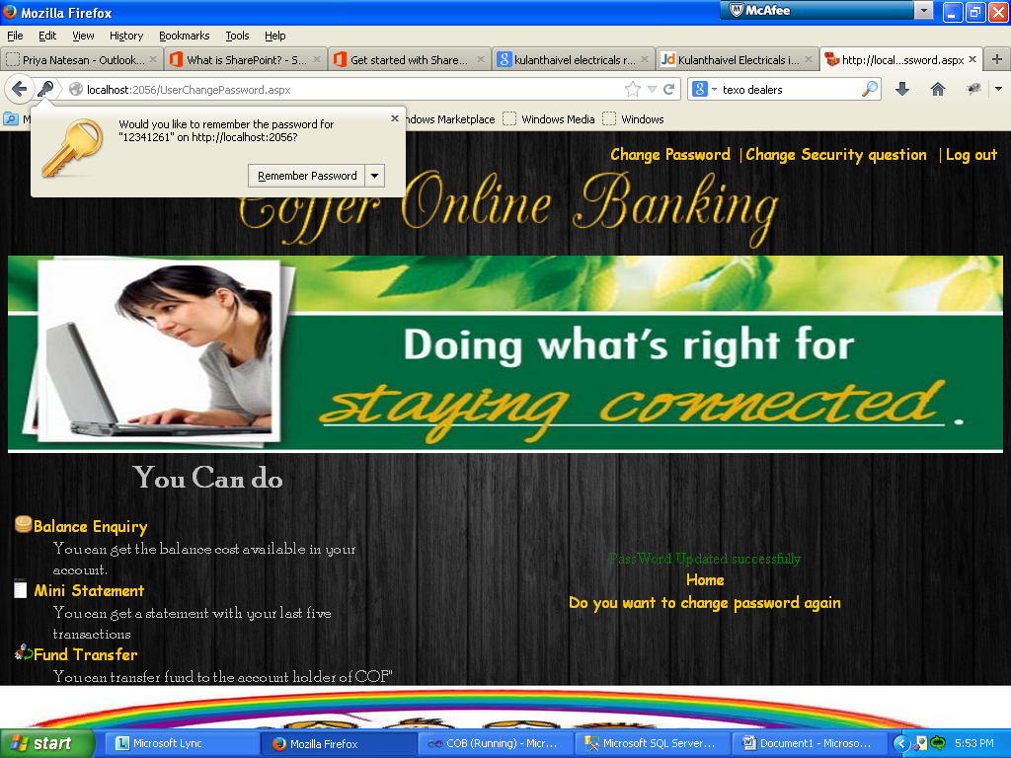

**Forgot Password:**

This is a useful module if the user forgets the password. It is done with the help of security question. The user should give the right answer for the security question. If so the password will be mailed to the user’s mail id.

**Admin Modules:**

**Admin Home Page:**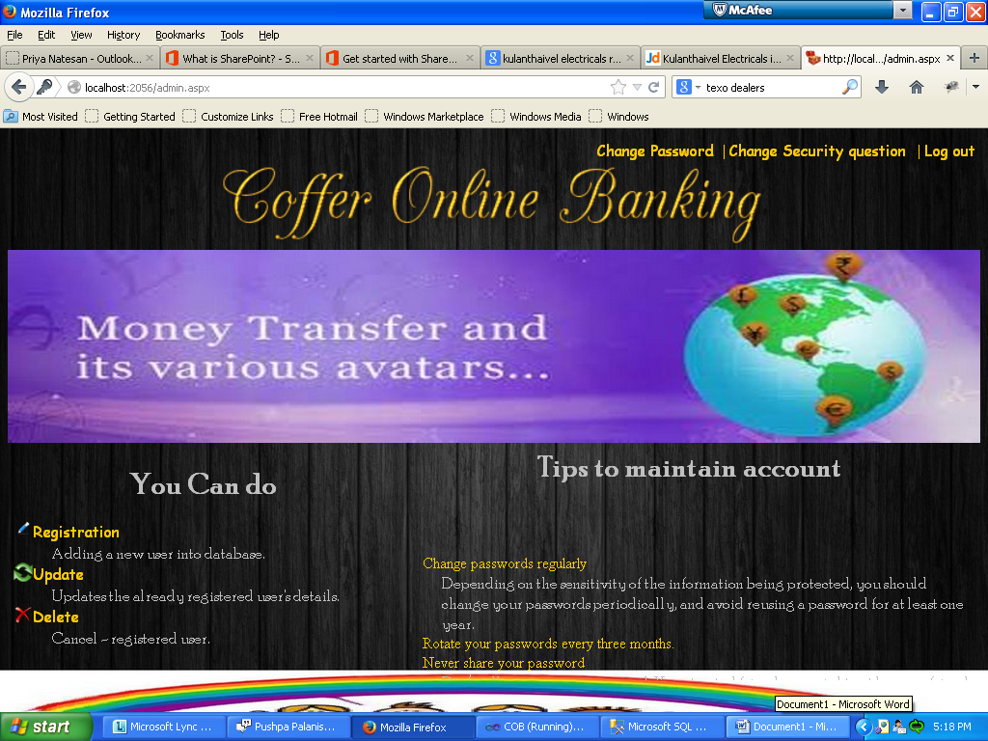

**Account Creation:**

This module adds a new account holder details submitted by the requester (customer requests for the account) to the bank database. The type of account is chosen by the requester. The account number is automatically generated by the system in an incremental basis.

**Admin - Registration Page:**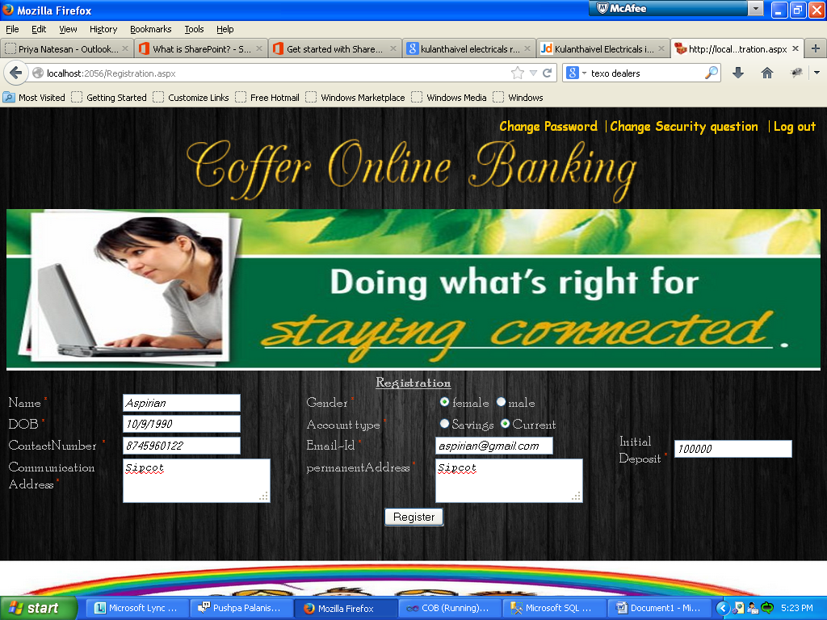

**Admin - Registration Success Page:**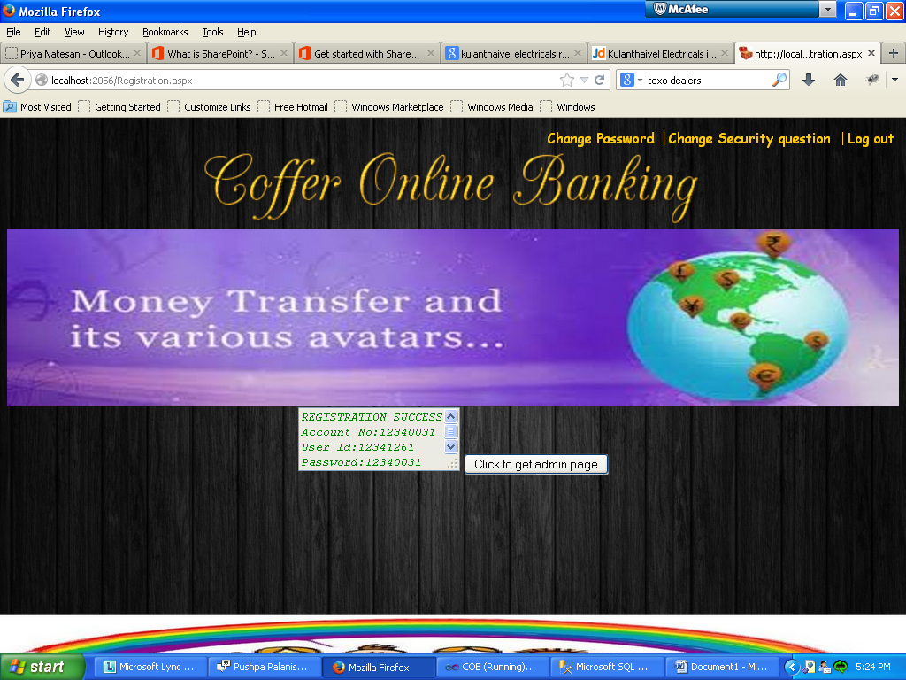

**Managing Account:**

There are two.

1. **Viewing Details:**

This module allows the admin to view an account holder details. Administrator has to give the account number to view the account holder’s information.

**ii. Editing Account Details:**

This module allows the admin to edit or update or delete an account when needed. Administrator has to give the account number to view the account holder’s information.

**Account Holder Modules:**

**Account Holder Home Page:**

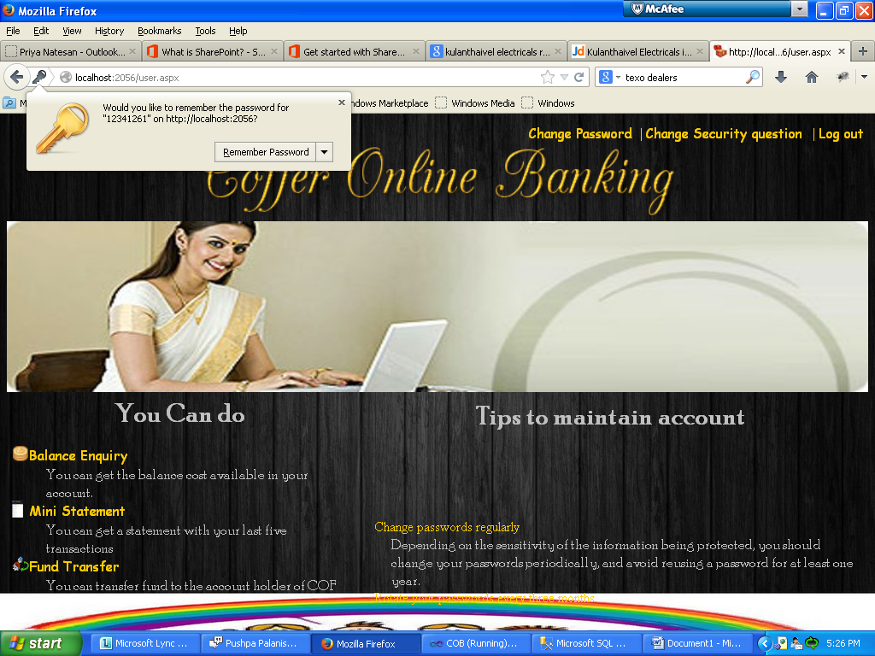

**Balance Enquiry:**

This module allows customer to enquire the current balance in his\ her account.

**Account Holder Balance Enquiry Page:**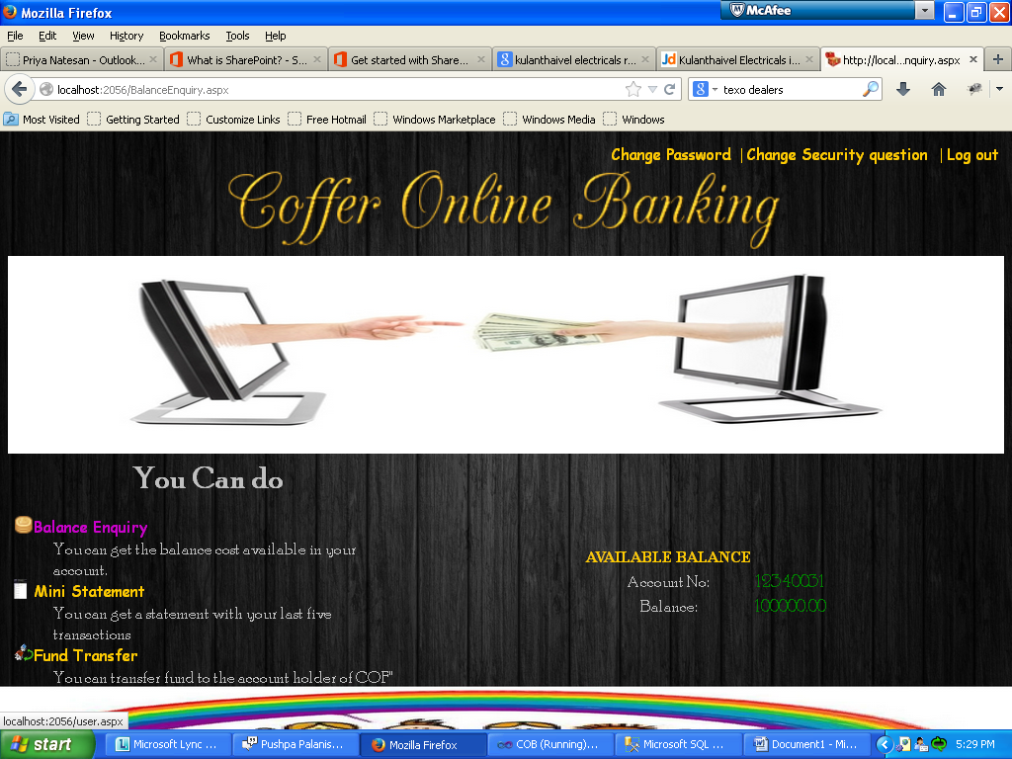

**Funds Transfer:**

This module allows the customer to transfer fund from the account holder’s account to the other accounts of the same bank.

**Account Holder Fund Transfer Page:**

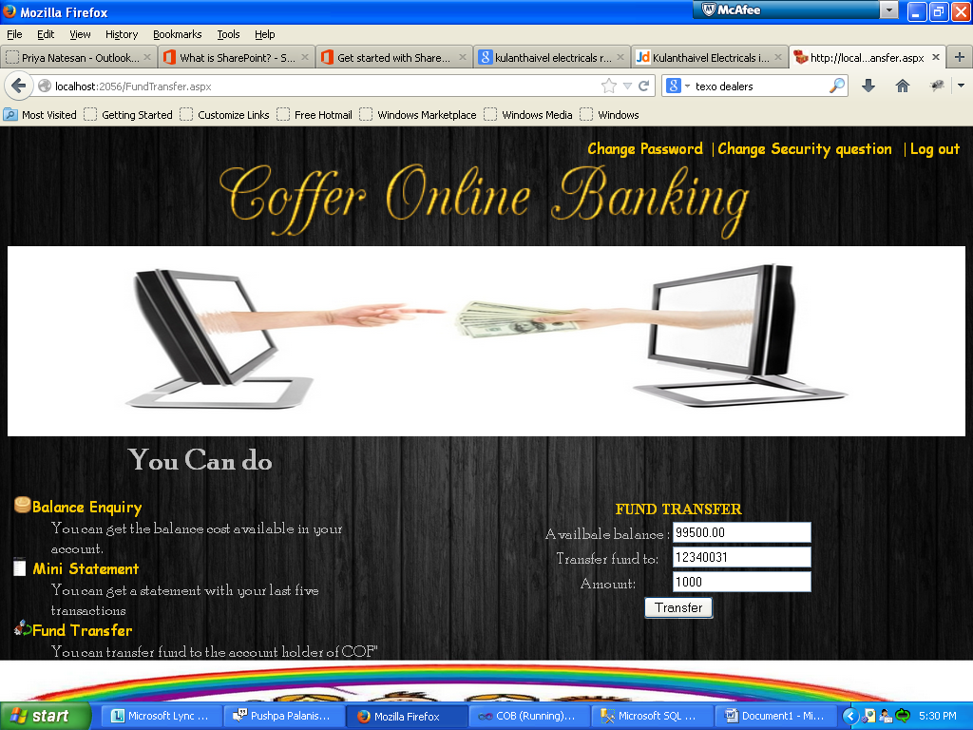

**Account Holder Fund Transfer – Success Page:**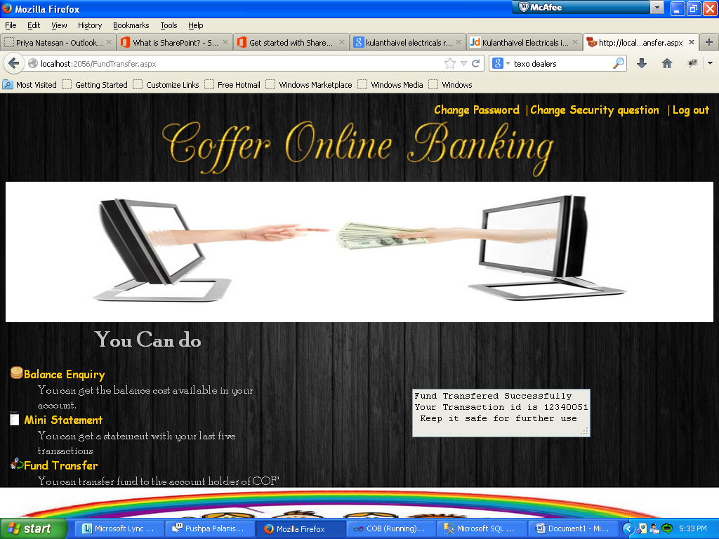

**Mini Statement:**

Account Summary allows the user to get the summary of the last five transactions by providing the account number. The summary provides all the details of transaction including transaction id, date, transaction amount, from and to account numbers.

**3. Table Design**

**Table 1: Account Holder**

|  |  |  |  |
| --- | --- | --- | --- |
| **Field Name** | **Data Type** | **Constraints** | **Description** |
| EMailId | Varchar(20) | Primary Key | E-mail id of the account holder. |
| AccountNo | BigInt | Foreign Key | Account number assigned by the bank. |
| HolderName | Varchar(20) | Not Null | Name of the account holder. |
| DateofBirth | Date | Not Null | Date of birth of the account holder. |
| Gender | Char(1) | Not Null | Gender of the account holder. |
| PermenantAddress | varchar(max) | Not Null | Permanent address of the account holder. |
| CommunicationAddress | varchar(max) | Not Null | Address for communication of the account holder. |
| ContactNo | Varchar(10) | Not Null | Contact phone number of the account holder. |
| IsActive | Char(1) | Not Null | Determines the activation of the account holder. |
| DateCreated | Date | Not Null | Account creation date. |
| CreatedBy | Varchar(20) | Not Null | Name of the admin who creates the account |
| DateModified | Date | Not Null | Record modified date. |
| ModifiedBy | Varchar(20) | Not Null | Name of the admin who modified the account. |
| UserId | BigInt | Foreign Key | Log in id of the account holder. |

**Table 2: Account**

|  |  |  |  |
| --- | --- | --- | --- |
| **Field Name** | **Data Type** | **Constraints** | **Description** |
| AccountNo | BigInt | Primary Key | Account number assigned by the bank. |
| AccountType | Char(1) | Not Null | Holds the type of the account given by the account holder. |
| Balance | Decimal(13,2) | Not Null | Holds the maximum balance of the AccountNo |
| DateCreated | Date | Not Null | Account creation date. |
| CreatedBy | Varchar(20) | Not Null | Name of the admin who creates the account |

**Table 3: Transaction**

|  |  |  |  |
| --- | --- | --- | --- |
| **Field Name** | **Data Type** | **Constraints** | **Description** |
| TransactionId | BigInt | Primary Key | Id number of the transaction. |
| AccountNo | BigInt | Foreign Key | Account number assigned by the bank. |
| AccountNoTo | BigInt | Not Null | The account in which the cash is going to be credited. |
| TransactionDate | Date | Not Null | Date of the transaction. |
| TransactionAmount | Decimal(13,2) | Not Null | Holds the value of the fund transferred. |

**Table 4: Login**

|  |  |  |  |
| --- | --- | --- | --- |
| **Field Name** | **Data Type** | **Constraints** | **Description** |
| UserId | BigInt | Primary Key | Id to log in into the system. |
| Password | Varchar(20) | Not Null | Password of the corresponding UserId |
| SecurityQuestionId | Int | Foreign Key | Id of the security question for password recovery. |
| Answer | Varchar(20) | Not Null | Answer given by the account holder for the security question. |

**Table 5: SecurityQuestion**

|  |  |  |  |
| --- | --- | --- | --- |
| **Field Name** | **Data Type** | **Constraints** | **Description** |
| SecurityQuestionId | Int | Primary Key | Id of the security question for password recovery. |
| SecuityQuestion | Varchar(20) | Not Null | Question. |

**Table Design Daigram**

